Dsa0136 OBJECT ORIENTED PROGRAMMING WITH C++

name -ch.vamsi krishna

reg -192110482

__________________________________________________

printing your name:-

Program-

#include <iostream>

using namespace std;

int main()

{

cout<<"\nMy name is Rajath";

}

Output-

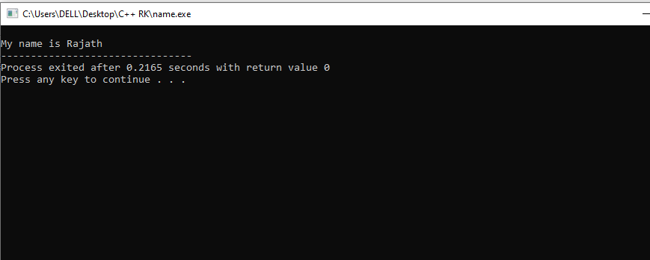

2. print the sum of 2 numbers?

Program-

#include <iostream>

using namespace std;

int main()

{

int a,b,c;

cout<<"enter the values for addition:";

cin>>a>>b;

c=a+b;

cout<<"\naddition of 2 numbers is:"<<c;

return 0;

}

Output-

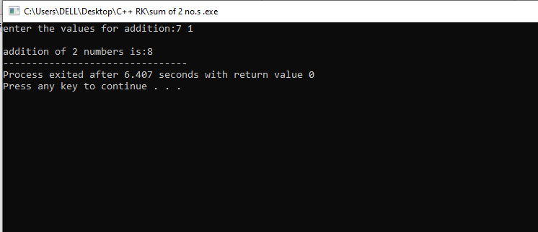

3. finding the biggest of 2 no.s

PROGRAM-

#include <iostream>

using namespace std;

int main()

{

int a,b;

cout<<"enter 2 values:";

cin>>a>>b;

if(a>b)

{

cout<<"the greatest no. is"<<a;

}

else

{

cout<<"the greatest no. is"<<b;

}

return 0;

}

OUTPUT-

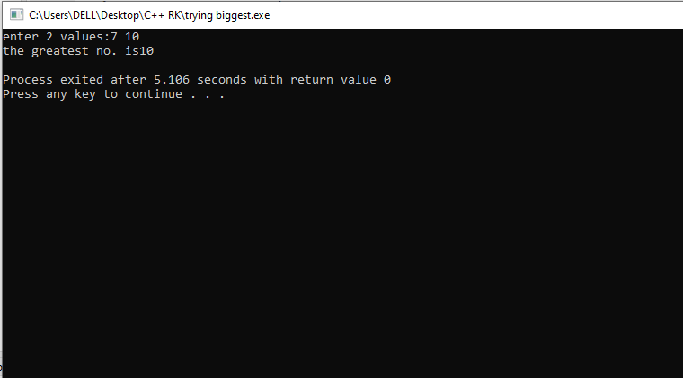

4. find the goven no.is odd or even

PROGRAM-

#include <iostream>

using namespace std;

int main()

{

int a;

cout<<"enter the valuue of a:";

cin>>a;

if(a%2==0)

{

cout<<"the entered no."<<a<<"is even";

}

else

{

cout<<"the entered no."<<a<<"is odd";

}

return 0;

}

OUTPUT-

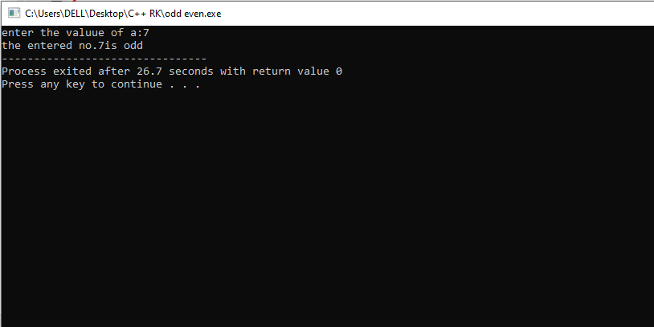

5. check wether the person is eligible for voting

PROGRAM-

#include<iostream>

using namespace std;

int main()

{

int age,res=age/1;

cout<<"enter the age:";

cin>>age;

if(int(age)>0 && res*1==age)

{

if(age>=18)

{

cout<<"the person is eligible for voting";

}

else

{

cout<<"the person is eligible to vote after"<< 18-age<<"years";

}

}

else

{

cout<<"invalid age";

}

return 0;

}

OUTPUT –

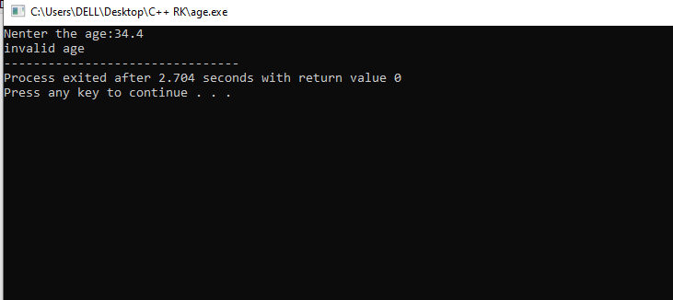

print the student report

PROGRAM-

#include <iostream>

using namespace std;

int main()

{

int reg_no,m1,m2,m3;

char name[20];

cout<<"\nenter the name:";

cin>>name;

cout<<"\nenter the registration number:";

cin>>reg_no;

cout<<"\nenter the 3 marks:";

cin>>m1>>m2>>m3;

int total=m1+m2+m3;

cout<<"\nthe total marks obtained are:"<<total;

float avg=total/3;

if(m1>0 && m1<=100 && m2>0 && m2<=100 && m3>0 && m3<=100)

{

cout<<"\nthe average result is:"<<avg;

if(avg>90)

{

cout<<"\nS grade";

}

else if(avg>80)

{

cout<<"\nA grade";

}

else if(avg>70)

{

cout<<"\nB grade";

}

else if(avg>60)

{

cout<<"\nC grade";

}

else if(avg>50)

{

cout<<"\nD grade";

}

else

{

cout<<"\nFail";

}

}

else

{

cout<<"\n invalid marks";

}

return 0;

}

